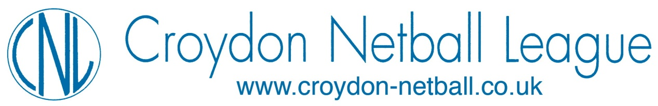

SPORTS GRANT SCHEME
TERMS & CONDITIONS

The Croydon Netball League operate a Sports Grant Scheme aimed at supporting Clubs, individual players, officials and volunteers which, in turn, will benefit the individual, Clubs and the League. Any applicant should be affiliated through their Club to the England Netball Association.

These Grants will be judged on individual merit and will not be excessive.

Grants will be available for consideration under the following categories and should meet the following criteria:-

Players: Any player can apply who has been selected for Surrey County Satellite
Academies and Development Squads. You will be able to bring back the experiences to your Club and team, ultimately benefitting the standard of play for the League.

Please provide a confirmation of acceptance document from the Coach, an email will be acceptable.

Clubs: Can request support for setting up Junior Sections, including costs relating to purchase of balls, bibs, venue hire and coaches/umpires in the first instance.

It will also be possible to request equipment in following years.

Clubs should provide details of costs for items requested together with a copy of their Constitution and accounts.

Officials: A contribution towards attending courses for officiating, i.e.
Umpiring, Coaching, Tutoring, Scoring etc., will be considered. Course dates should be included in the application as payment will only be available following the course, details of which will be verified. You will also be agreeing to supporting CNL by Officiating within the League and supporting your Club by applying your knowledge and expertise.

A copy of the course application form should be attached, if possible.

Other: Any other request not covered by the above will be considered.

Completed forms to be sent to: Treasurer, CNL or emailed. Details on Sports Grant Application Form.

